

SRI LANKA INSTITUTE OF INFORMATION TECHNOLOGY

[Enterprise Standards and Best Practices for IT Infrastructure](http://courseweb.sliit.lk/course/view.php?id=137)

**4th Year 2nd Semester 2016**

Name: Chanuchan Sivalingam

IT No: IT13042752

**What is V-Motion?**

VMotion is a powerful feature that allows you to quickly move an entire running VM from one ESX host to another without any downtime or interruption to the VM. This is also known as a "hot" or "live" migration. VMware VMotion enables the live migration of running virtual machines from one physical server to another with zero downtime, continuous service availability, and complete transaction integrity. It is transparent to users. Automatically optimize and allocate entire pools of resources for maximum hardware utilization and availability. Perform hardware maintenance without any scheduled downtime. Proactively migrate virtual machines away from failing or underperforming servers.

**How does V-Motion work?**

The entire state of a VM is encapsulated and the VMFS filesystem allows both the source and the target ESX host to access the VM files concurrently. The active memory and precise execution state of a VM can then be rapidly transmitted over a high-speed network. The VM retains its network identity and connections, ensuring a seamless migration process as outlined in the following steps.

1. The migration request is made to move the VM from ESX1 to ESX2.
2. VCenter Server verifies that the VM is in a stable state on ESX1.
3. VCenter Server checks the compatibility of ESX2 (CPU/networking/etc.) to ensure that it matches that of ESX1.
4. The VM is registered on ESX2.
5. The VM state information (including memory, registers, and network connections) is copied to ESX2. Additional changes are copied to a memory bitmap on ESX1.
6. The VM is quiesced on ESX1 and the memory bitmap is copied to ESX2.
7. The VM is started on ESX2 and all requests for the VM are now directed to ESX2.
8. A final copy of the VM's memory is made from ESX1 to ESX2.
9. The VM is unregistered from ESX1.
10. The VM resumes operation on ESX2.

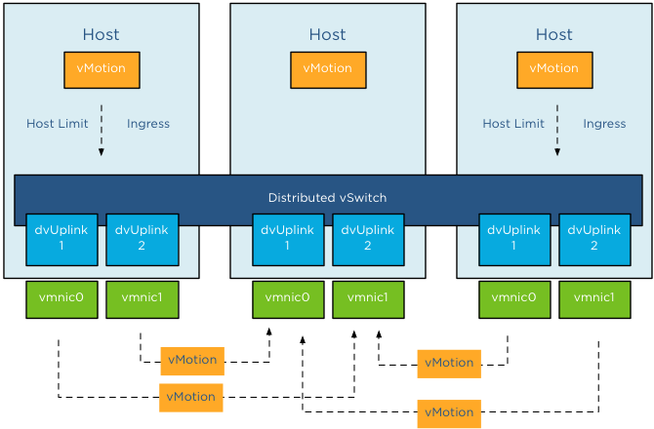

**Requirements to Configure V-Motion**

Certain conditions must be fulfilled so that the server migration process can run without problems or failures as V-Motion is arbitrated in an active virtual machine. The requirements are as follows:

1. CPU Compatibility:

|  |  |
| --- | --- |
|  | * Host CPU family and model |
|  | * Settings in the BIOS that might disable CPU features |
|  | * ESX version running on the host |
|  | * The virtual machine's compatibility setting |
|  | * The virtual machine's guest operating system |

1. V-Motion Interface – Minimum 1GB adapter
2. Shared central mass storage
3. Same naming for virtual port groups
4. Sufficient resources on the target host
5. At least one vSphere essentials plus license on the corresponding ESX host.